**Java CRUD code**

Database credentials, SQL statements and main menu code

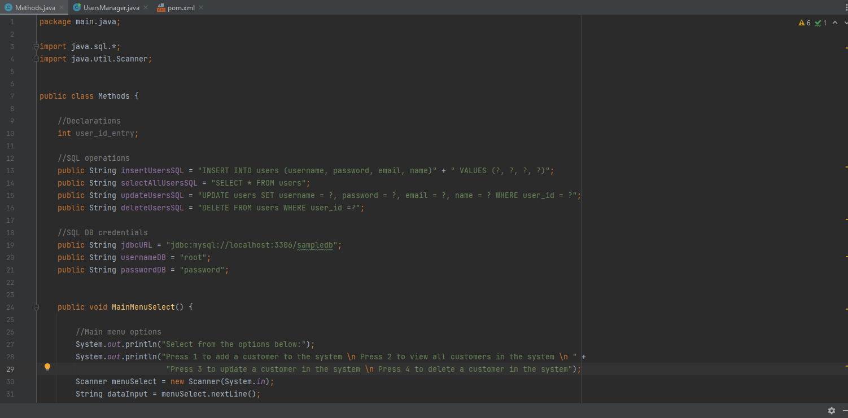

Create user code:

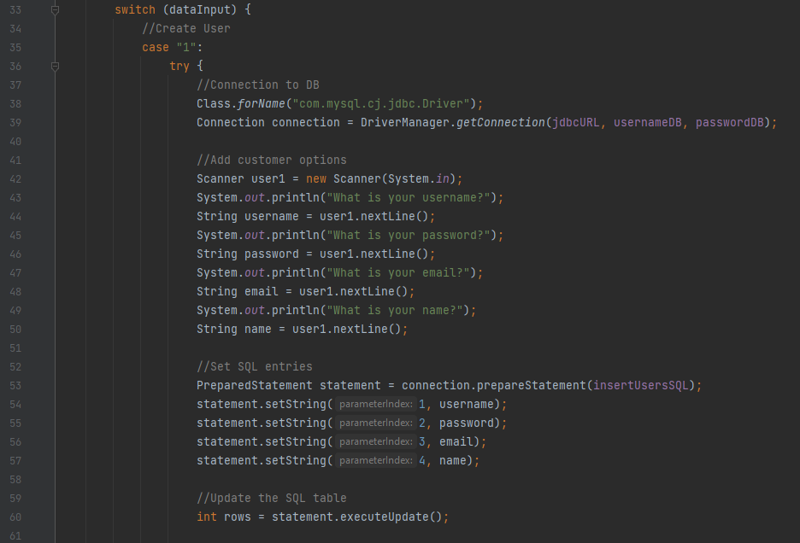

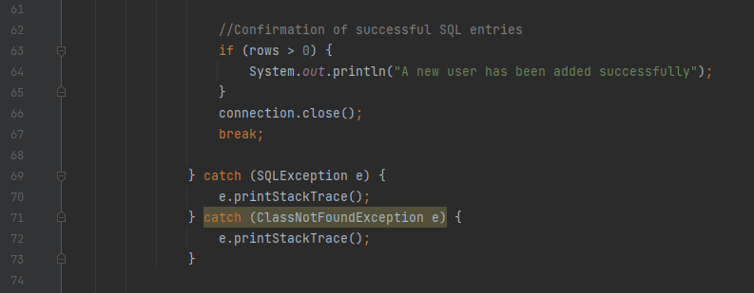

View users code:

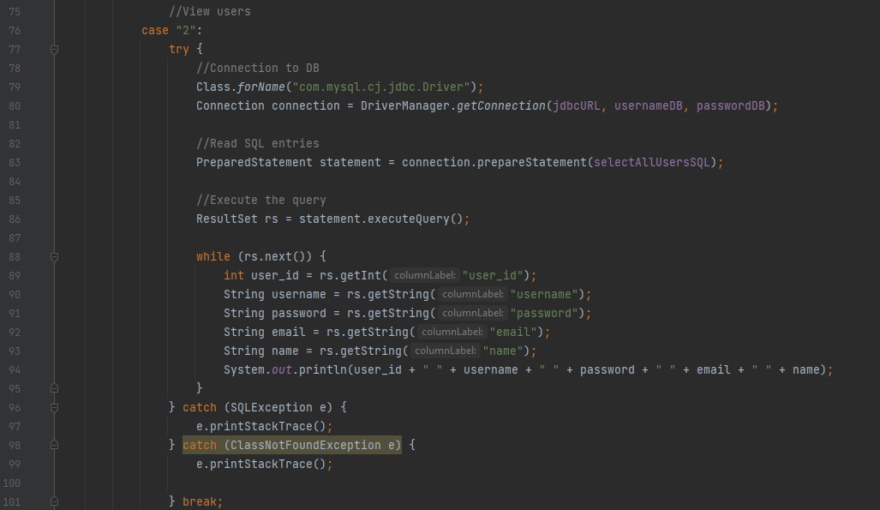

Update users code:

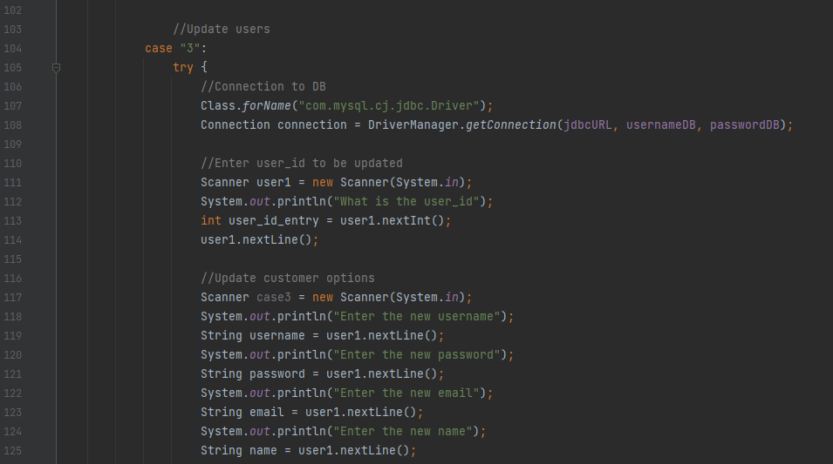

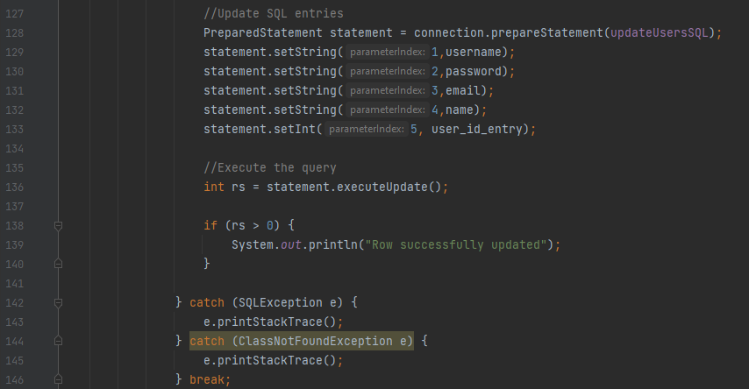

Delete users code

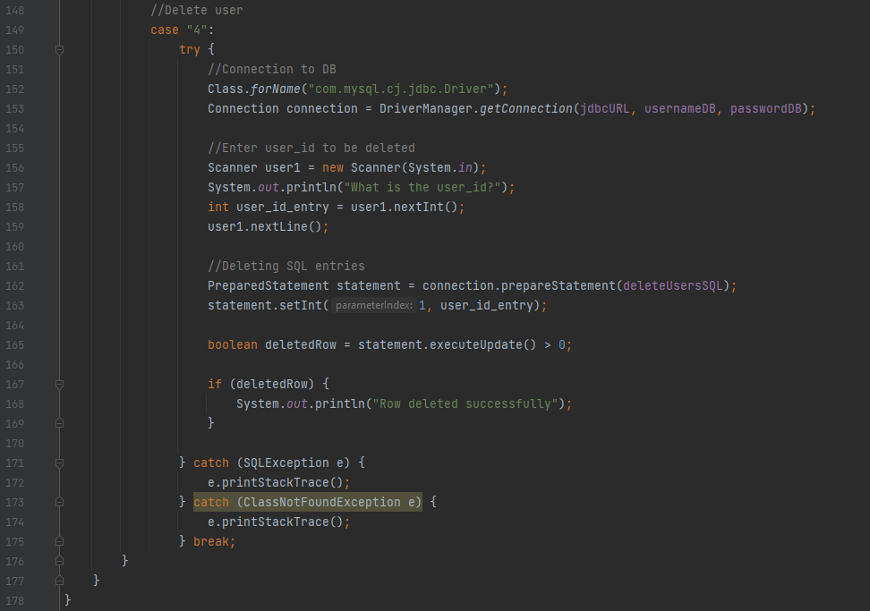

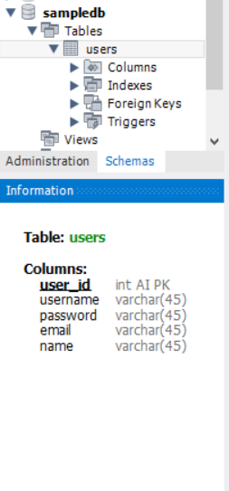**SQL Table Creation**

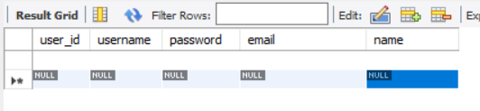

**Demonstration of running the code in the console**

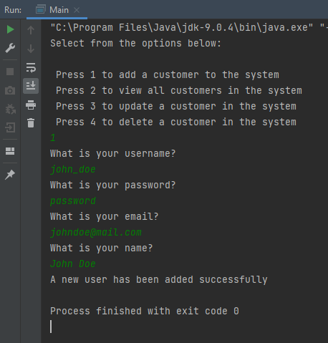**Create user:**

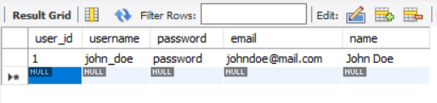

**View users:**

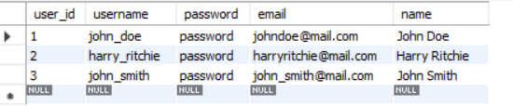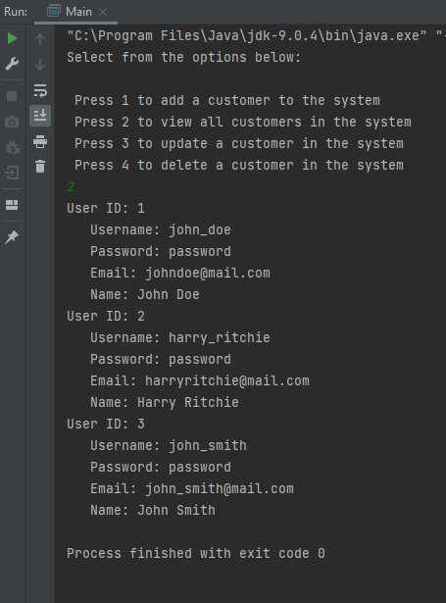

**Update user:**



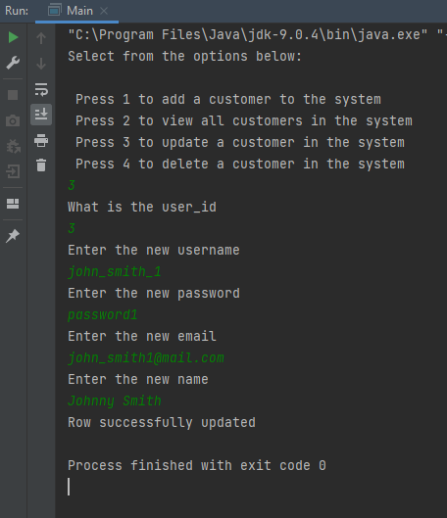

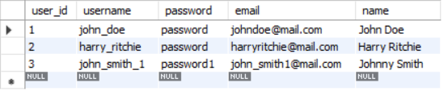

**Delete user:**



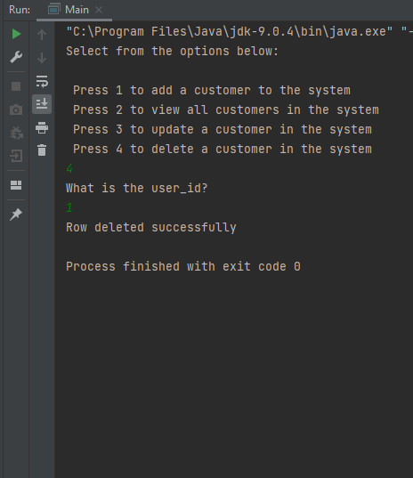

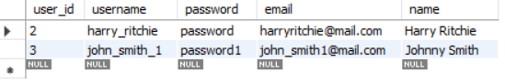

**GitHub Repo Set-Up**

GitHub Branches for each feature:

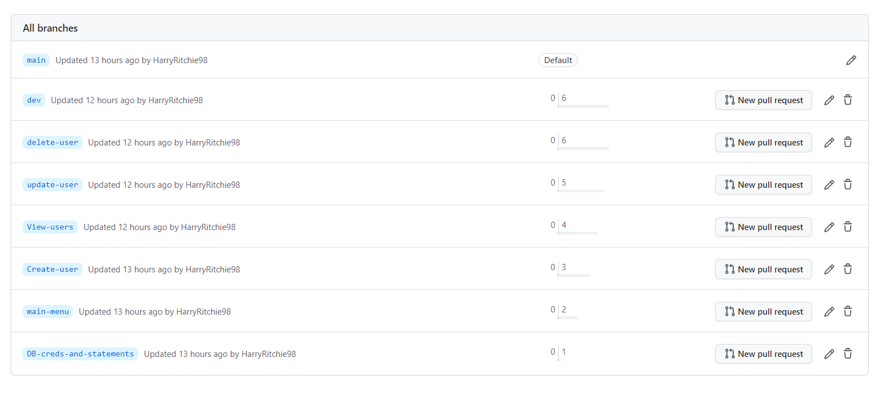

Individual commits of each feature to the dev branch:

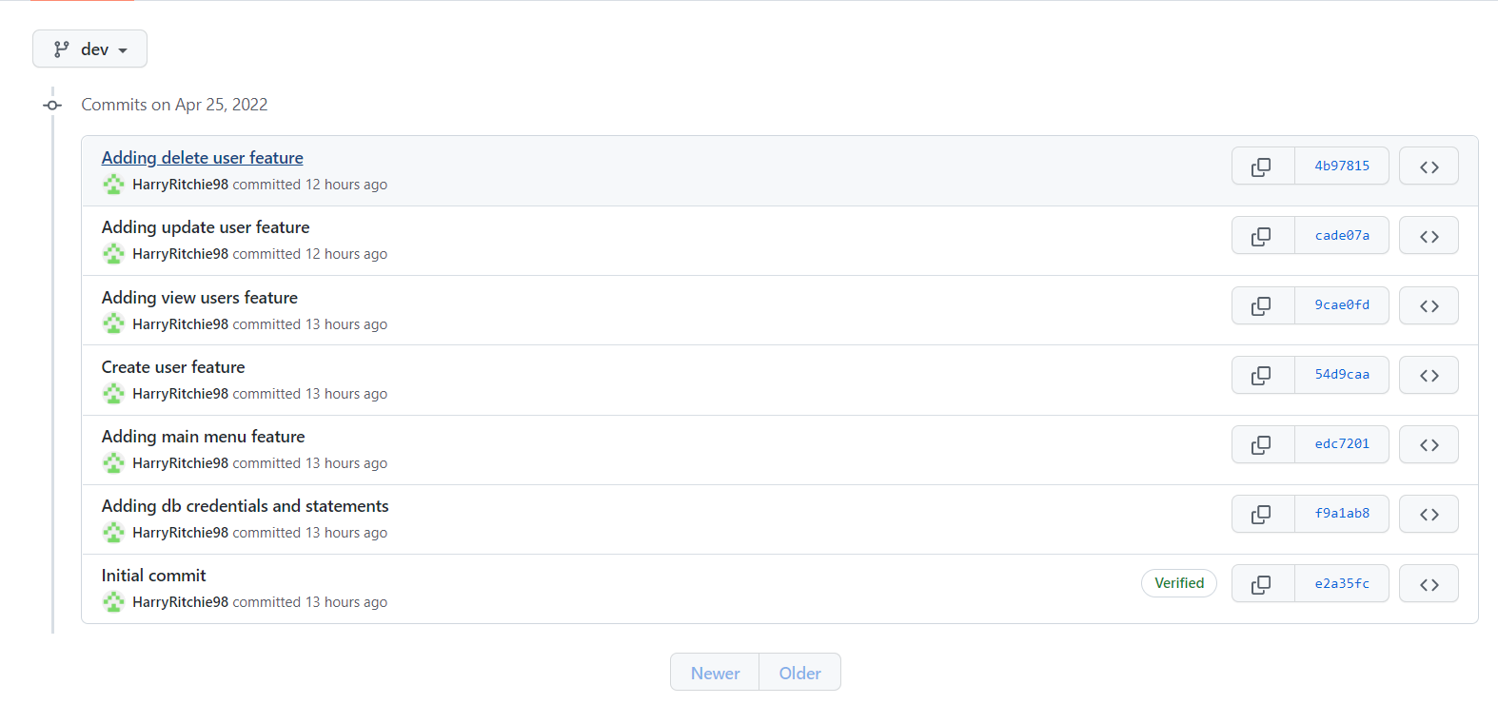

**Jenkins**

Connecting GitHub repo for Jenkins build automation:

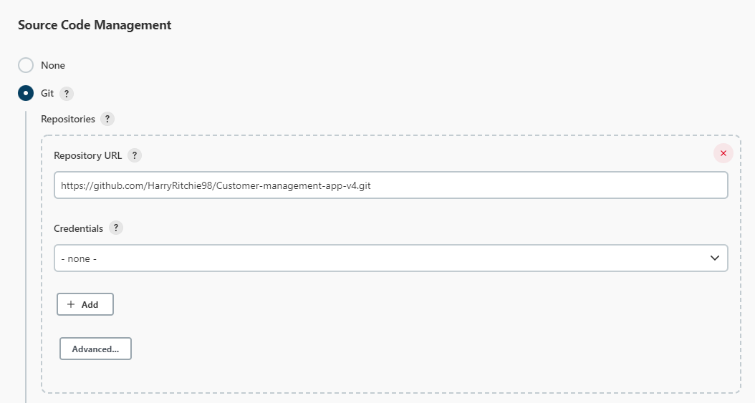

Configuring Jenkins SCM polling to check new GitHub features once every two hours at 45 minutes past the hour starting at 9:45 AM and finishing at 3:45 PM every weekday:

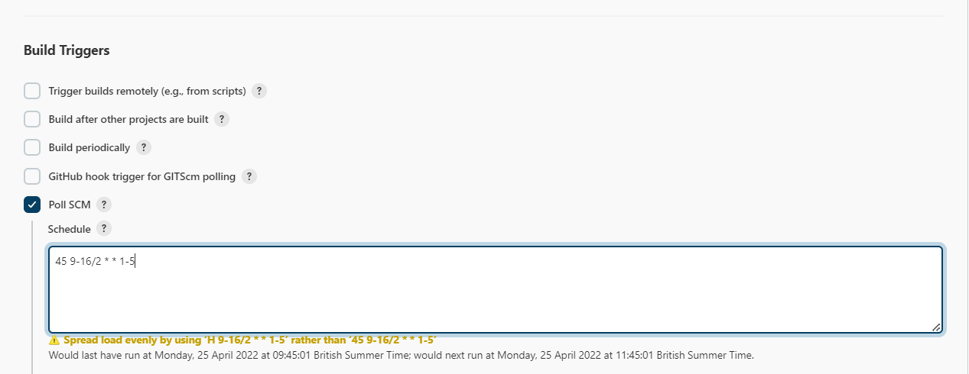

Builds triggered automatically by Jenkins:

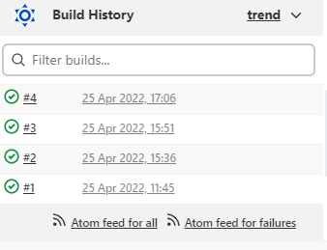

**Maven build of application**

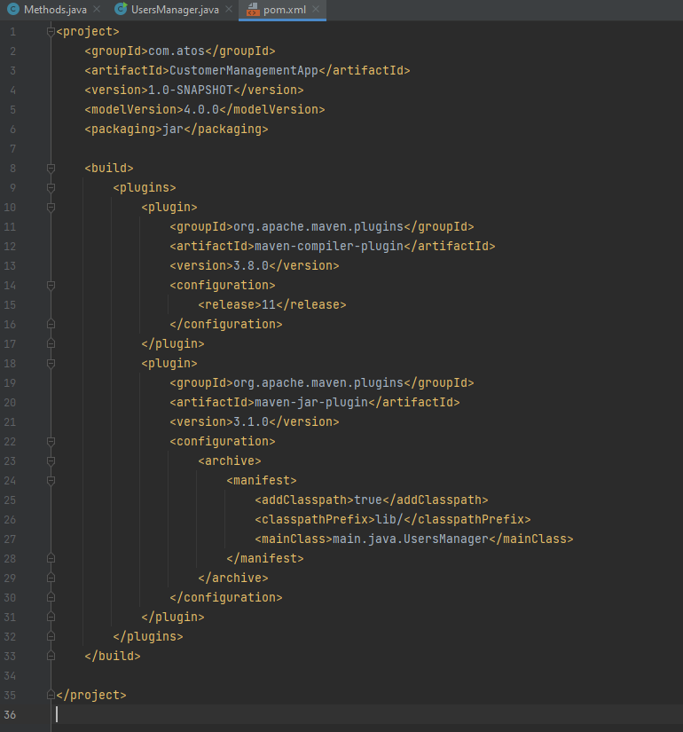POM xml file structure for adding Java compiler and .jar plug ins to allow build of application .java file to executable .jar format.

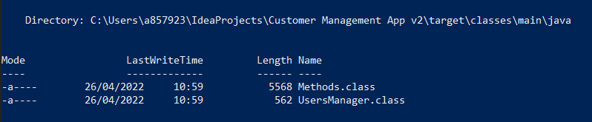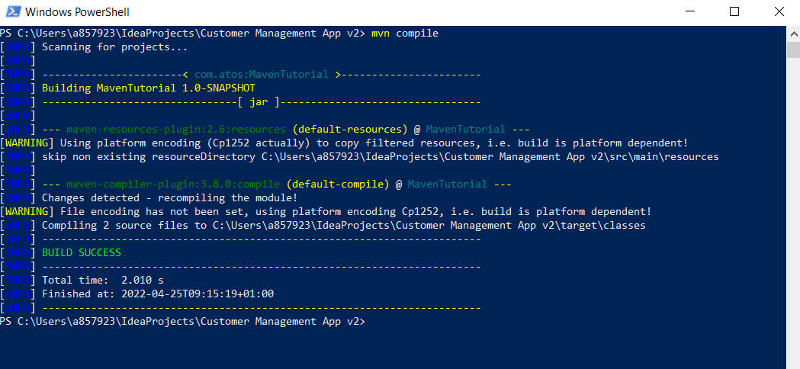Compiling Methods.java and Users Manager.java file to .class files

Packaging the application into a .jar exectuable file:

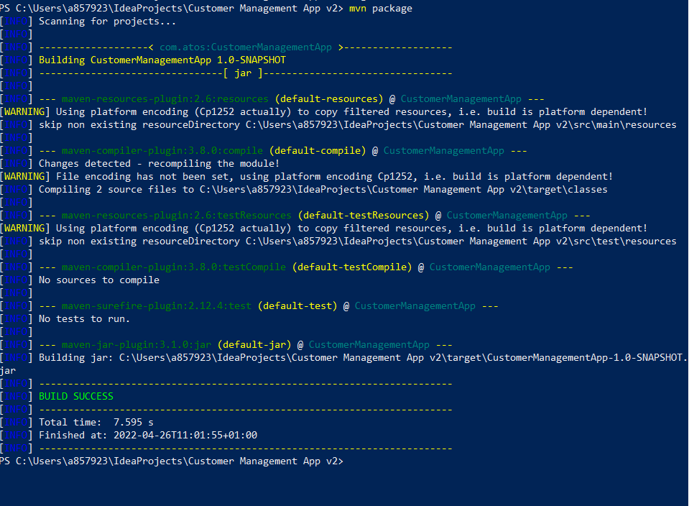

Running the executable .jar file in the CLI:

I had an error when trying to connect to the database

